**HA 2.1:**

**A. Use the help function to explore what the series gold, woolyrnq, and gas represent**

1. **gold**: This series represents daily morning gold prices in US Dollars for the time period 1/1/1984 - 3/31/1989. It is a time series with 1,108 observations; no source is provided.

*Sample data:*

Time Series:  
Start = 1   
End = 6   
Frequency = 1   
[1] 306.25 299.50 303.45 296.75 304.40 298.35

1. **woolyrnq:** This series represents quarterly production of woolen yarn in Australia in tonnes for the time period Mar 1965-Sept 1994. It is presented as a time series with 119 observations and was sourced from the Time Series Data Library (https://pkg.yangzhuoranyang.com/tsdl/).

*Sample data:*

Qtr1 Qtr2 Qtr3 Qtr4  
1965 6172 6709 6633 6660  
1966 6786 6800 6730 6765

1. **gas:** This series represents monthly Australian gas production 1956-1995 (no units provided). It is presented as a time series sourced from the Australian Bureau of Statistics.

*Sample data:*

Jan Feb Mar Apr May Jun Jul Aug Sep Oct Nov Dec  
1956 1709 1646 1794 1878 2173 2321 2468 2416 2184 2121 1962 1825  
1957 1751 1688 1920 1941 2311 2279 2638 2448 2279 2163 1941 1878

**B. Use autoplot to plot each in separate plots:**

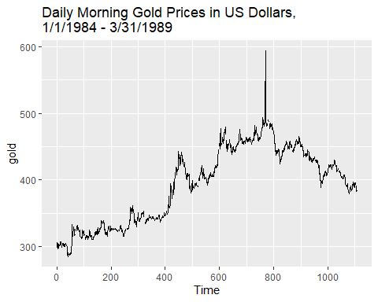

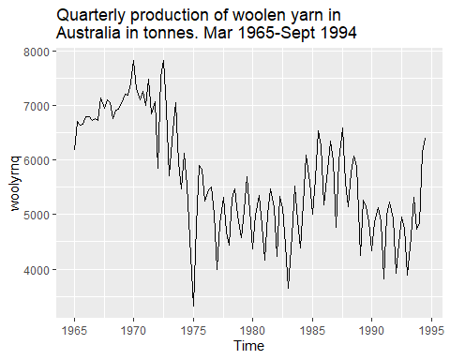

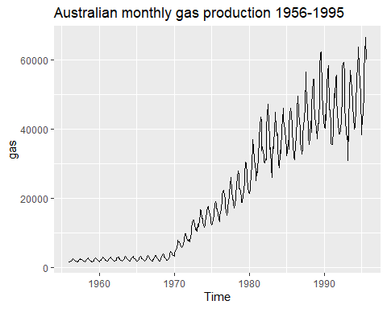

**C. What is the frequency of each series?**

By using the “frequency” function, we can see these patterns in our three sample time series:

1. **gold**: This data is daily (business days) and has a frequency of one observation per unit of time (day).
2. **woolyrnq**: This data is quarterly, and has a frequency of four observations per unit of time (year).
3. **gas**: This data is monthly, and has a frequency of 12 observations per unit of time (year).

[1] 1

[1] 4

[1] 12

**D. Use which.max to spot the outlier in the gold series? Which was it?**

The outlier in the gold series was observation #770

[1] 770

**Code for reference:**

# Load libraries

library(tidyverse)

library(dplyr)

library(ggplot2)

library(fpp2)

library(mlbench)

library(RColorBrewer)

library(scales)

#-------------------------

# Section A - Use help fx to explore three datasets in forecast pkg

#-------------------------

?gold

head(gold)

?woolyrnq

head(woolyrnq,8)

?gas

head(gas,24)

#-------------------------

# Section B - Autoplot

#-------------------------

autoplot(gold) + ggtitle ("Daily Morning Gold Prices in US Dollars,

1/1/1984 - 3/31/1989")

autoplot(woolyrnq) + ggtitle ("Quarterly production of woolen yarn in

Australia in tonnes. Mar 1965-Sept 1994")

autoplot(gas) + ggtitle ("Australian monthly gas production 1956-1995")

#-------------------------

# Section C - Frequency

#-------------------------

freq_gold <- frequency(gold)

freq_gold # returns frequency of 1

freq_woolyrnq <- frequency(woolyrnq)

freq_woolyrnq # returns frequency of 4

freq_gas <- frequency(gas)

freq_gas # returns frequency of 12

#-------------------------

# Section D - WhichMax fx

#-------------------------

which.max(gold)